**The Death Contract**

Developed by revolverrob

**Contents**

1. **Description**
2. **Credits**
3. **Story**
   1. **Characters**
   2. **Routes**
   3. **Outline**
4. **Graphics**
5. **Audio**
6. **Design Notes**

For the “My First Time Game Jam”

Game Engine: Ren’Py

Genre: Visual Novel

Jam Theme: Pride

**Description**

Valeria Jimenez is a college sophomore on the verge of losing her scholarship. She’s broke, failing her classes, has few friends, and she’s desperate for *anything* that can help her. Enter the Entity: a demon-like creature that strikes a deal with Valentia that will solve all her problems. She just has to do one thing: sabotage her long time best friend Darren Romero.

♥ Play as Valentia! Will it be friendship over all, or is it every person for themselves?

♥ Featuring a text-messaging system developed by nadianova

♥ Six different endings based on your Friendship, Morality, and Pride!

**Credits**

Text messaging for Ren’Py developed by nadianova: (<https://nadianova.itch.io/phone-message-system-for-renpy>)

Desk photo: Photo by [Nikita Kachanovsky](https://unsplash.com/@nkachanovskyyy?utm_source=unsplash&utm_medium=referral&utm_content=creditCopyText) on [Unsplash](https://unsplash.com/search/photos/computer?utm_source=unsplash&utm_medium=referral&utm_content=creditCopyText)

Classroom photo: Photo by [Miguel Henriques](https://unsplash.com/@miguel_photo?utm_source=unsplash&utm_medium=referral&utm_content=creditCopyText) on [Unsplash](https://unsplash.com/search/photos/lecture-hall?utm_source=unsplash&utm_medium=referral&utm_content=creditCopyText)

**STORY**

**Characters**

* Protagonist: Valeria Jimenez
  + Background: She’s in a top university on a scholarship, but she’s been stressing so intensely while working a part-time that her grades are starting to slip and she’s on the verge of being kicked out of college. If she gets expelled from school, she’ll lose all support from her parents. She’s also pretty lost in life, with few vague passions and she doesn’t really know what to pursue.
  + Goal - She has a final exam in statistics, psychology, and literature. These are classes she’s struggling in. If she passes her finals, she’ll be able to keep her scholarship.
  + Motive - She wants to keep attending college and ultimately figure out what it is she wants to do. The first step in that is keeping her scholarship and not losing her parent’s support.
  + Personality - She’s desperate and willing to do what it takes, and when the opportunity to make a deal with a mysterious entity presents itself she takes it- in exchange she must complete a task. If she fails, the entity gets her soul. The player then decides what routes she takes. She can fail and lose her life, or be strong and outsmart the entity.
* Supporting Characters
  + Darren Romero
    - Motives: He’s extremely driven and always trying to cheer Valeria up whenever she’s down. He has aspirations to become a future legislator in order to change society, as he’s an activist who cares about social injustices and especially the environment. Valeria admires his determination, but deep down is envious. The Entity takes advantage of this envy.
    - Relationship: Best friend since high school.
* Antagonist: The Entity. They are completely genderless and inhuman, but appear as an ethereal woman in order to appeal to Valeria.
  + Goal - They have malicious intentions, hoping to either gain Valeria’s soul or cause some mischief as a result of their deal. They make the deal because of this desire. However, the laws of this creature state that they must be fair, no matter what, so they cannot fully trick Valeria. Their contract is fair, so they view it as a win win. Valeria is totally capable of overcoming the challenges though, and being able to grow as a person and find the mental strength she needs to move on.
  + Points of friction - the initial meeting. The demon reveals itself through text which Valeria chooses to investigate. They then appear in her apartment and make her sign the contract.
  + The contract: If Valeria can complete this task, then her scholarship will be renewed for next year and she will pass her final exams. In exchange, she must sabotage Darren’s campaign for student body president. If she fails, the demon can take her soul.

**Routes**

Essentially a desperate, broke and lost college student decides to make her life easier by signing a Death Contract, a deal with a demon-like Entity that has powers to solve her problems.

* Common route: Signing the contract and going to class. Valeria will learn about Darren’s campaign efforts, and the Entity communicates that this is her chance. While Valeria goes about her day and spends time with Darren, she is faced with many choices that will change her statistics (Friendship, Pride, Morality). This will determine the choices that will open up to her.
* Diverging routes (3 tracked statistics = 6 possible combinations/endings)
  + Low Pride, Low Friendship, Low Morality
    - Results in directly sabotaging Darren’s campaign without regard for him at all. The terms of the contract are met and Valeria keeps her scholarship, but loses Darren’s friendship.
  + Low Pride, Low Friendship, High Morality
    - Results in sabotaging Darren’s campaign but refusing to buy into the Entity’s games and not directly hurting him at the cost of their friendship. (This is considered tricking the Entity while still meeting the terms of the contract.) Even though she loses his friendship in this route, she doesn’t feel horrible about it. He becomes President.
  + Low Pride, High Friendship, High Morality
  + High Pride, High Friendship, High Morality
    - Completely refusing the Entity and failing, getting kicked out of college but keeping Darren’s friendship and starting a new path in life. The Entity takes pity and decides to let Valeria go.
  + High Pride, Low Friendship, Low Morality
    - Even though Valeria has low friendship and morality, her pride prevents her from accepting the Entity’s help. She intends to help herself but is not able to succeed. This ending results in the Entity taking her soul after she loses Darren’s friendship.
  + High Pride, High Friendship, Low Morality

**\*Route notes:** The way I’m imagining it is that during the common route her stats will end up as described in the subheadings, then the route diverges. The different routes may be longer as she elaborately sabotages the campaign, converses with both the Entity and Darren, and gets the final result. Alternatively, the routes could be short as in the ones where she refuses and fails, because instead of going through all that the Entity simply takes her soul and the player immediately loses.

**Outline**

1. **Common route**
   1. **Valeria’s situation is revealed through her memory per a conversation with an academic advisor, then receives a strange text from an unknown number while in her apartment. This turns out to be the Entity, and the conversation results in Valeria signing the Death Contract and finding out the terms.**
   2. **She goes to class the next day and meets up with Darren Romero, her best friend. He lets her know about his campaign plans and wants her to be a part of it. The Entity communicates again and tells her that it’s her chance, and so she realizes what she must do. She’s hesitant, but from now on the player is faced with many choices about how she should react, what actions she should take, and even how she treats other people which will impact her statistics and determine what route she ends up in.**
   3. **Player choices that affect Friendship**
      1. Declining or accepting Darren’s request to help his campaign. Although the player can say no, they ultimately “change their mind” and join anyways. However Friendship stats goes down.
      2. Declining or accepting Darren’s request for lunch. Minor drop or raising points.
      3. Defending or joining in on trash talk about Darren.
   4. **Player choices that affect Morality**
      1. Choosing to cheat or not cheat on an exam.
      2. Defending or joining in on trash talk about Darren. (also affects Friendship.)
   5. **Player choices that affect Pride**

**GRAPHICS**

* UI
* Title Screen
* Font
  + Textbox
* Character Sprites
* Backgrounds
  + Images will be taken off Unsplash and filters will be applied on Photoshop.
  + Examples
  + 
  + 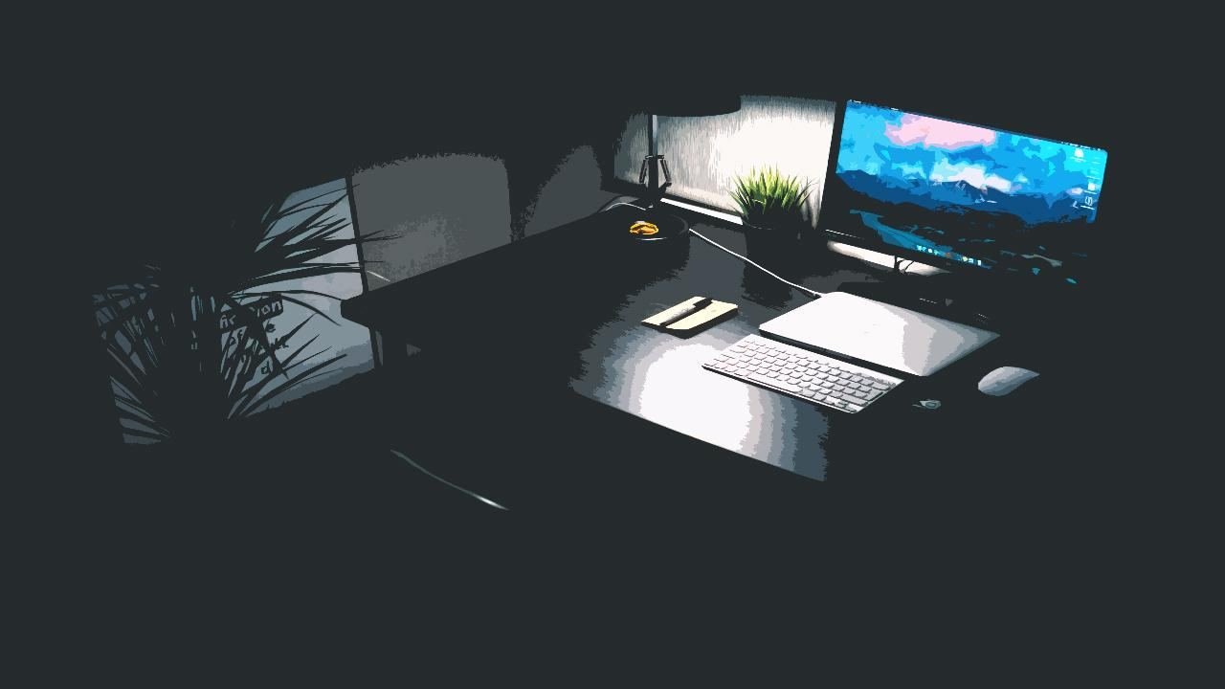
* CG’s
  + Painted in Procreate or Adobe Photoshop

**AUDIO**

* Music
* Sound Effects

**DESIGN NOTES**